Invoice

Nicholas Khan
105 Illicium Court
Cary, NC 27518
Phone: (860)230-4925
Nicholas.hart.khan@gmail.com
nicholashartkhan.wixsite.com/artwork

March 21st, 2025

Thank you for purchasing: Portrait of Edric
oil on canvas (unframed)
16 x 20 inches
Nicholas Khan, 2025
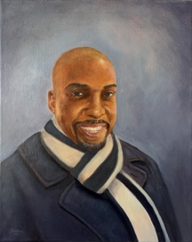

Buyer: Edric Purefoy
3343 Tarleton W,
Durham, NC 27713

Method of payment:
Cash
Check
Venmo
Cash App
Other

Portrait of Edric (including materials) $250
Hanging hardware $0

Total Due: $ 250

